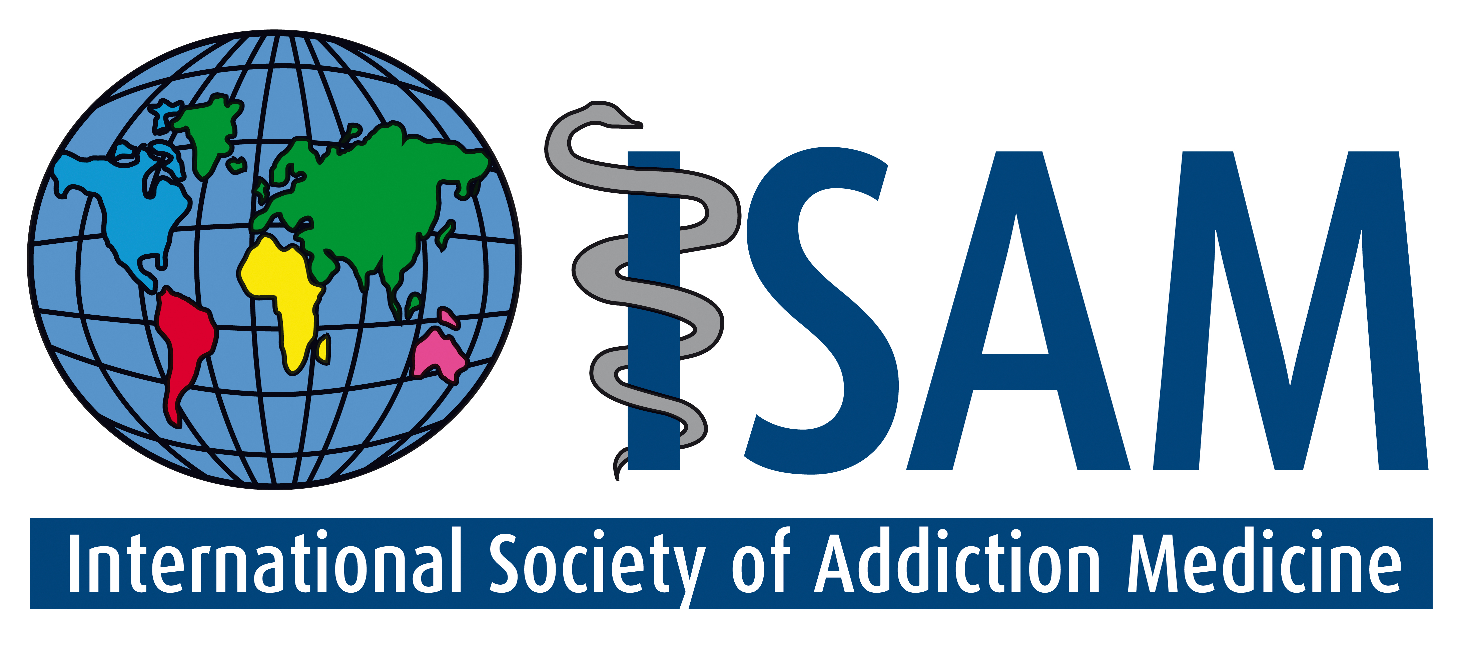
INTERNATIONAL CERTIFICATION
IN ADDICTION MEDICINE

Objective:
- ISAM’s Certification of Addiction Medicine is a credentialing process that assures the public that the holder has the pre-requisite knowledge competence to practice in that field within the confines of his/her medical license.
- To met the needs of an international membership of practicing physicians for standardized, valid and affordable credentialing in addiction medicine
Format:
- The examination is composed of 225 multiple choice questions testing knowledge and some clinical judgment. The exam will take 4 ½ hours and will be administered in two parts (2 hrs 15 min each) with a 15 min health break in between.

Content Areas:
I. Science/Clinical Foundation
II. Screening and Intervention
III. Drugs and Pharmacology
IV. Behavioral Approach
V. Social Therapy Systems
VI. Behavioral Addictions
VII. Medical Disorder and Pain
VIII. Psychiatric Comorbidities
IX. Youth and Special Populations

Eligibility Criteria:

This examination is a test of knowledge. While it does not certify clinical skill or competence, it does identify a physician who has demonstrated the degree of knowledge in the diagnosis and treatment of substance and other addictions commensurate with expertise in the field.
- Graduation from a medical school recognized by the World Health Organization.
- A valid license to practice medicine
- Good standing in medical community - (3) letters of recommendation including one current ISAM member.
- Documented medical practice over a 3- year period, continuous, in the addiction field
- Evidence of Continuing Education

FEES: A money order made payable to the International Society of Addiction Medicine for $800 US (non-ISAM members), $700 US (ISAM members), $725 US (for members of Affiliate Societies) is to be forwarded along with the application material to: ISAM c/o 47 Tuscany Ridge Terrace NW, Calgary AB T3L 3A5
Or by email: ISAM office admin@isamweb.org

PLEASE NOTE: Rejected applications will be refunded minus a $100US processing fee.

GENERAL INFORMATION

Specific Knowledge and Skills
The field of Addiction Medicine requires knowledge of pharmacology, psychiatry, general medicine, and psychology, as well as an understanding of the interaction of these disciplines. In order to insure that the trainee is well-versed in these areas, training programs must include both hands-on experience in clinical situations as well as classroom and seminar sessions.

1. Recognition of the signs and symptoms of the use of all of the major categories of drugs/psychoactive (mood-altering) substances, including sedatives (alcohol, benzodiazepines, barbiturates), stimulants (cocaine, amphetamine, tobacco), opioids, hallucinogens (marijuana, LSD, PCP) and inhalants (organic solvents, glue)

2. Recognition of the signs of abuse and dependence on these categories of drugs/substances.

3. Recognition of the signs of withdrawal from these major categories of drugs and knowledge and experience with the range of options for treatment of the withdrawal syndrome and its complications.

4. Recognition of the signs and symptoms of overdose and medical and psychiatric sequelae of these major categories of drugs and knowledge of the proper treatment of overdose.

5. Diagnosis of the medical sequelae of addiction, including hepatic, central nervous system, infectious, and HIV illness.

6. Recognition of the signs and symptoms of the psychological, social and spiritual problems accompanying the chronic use, abuse and dependence related to the major categories of drugs and knowledge of the range of management options.

7. Recognition and understanding of the special problems of drug/substance use, abuse and dependence during pregnancy and of the babies born to these mothers.

8. Recognition and understanding of the special problems of drug/substance use, abuse and dependence in target populations such as children and adolescents, women and seniors.

9. Recognition, education and appropriate treatment related to behavioral addictions like gambling, sex, internet, work, shopping etc.

10. Recognition, education and appropriate treatment of adjustment disorders and/or other concurrent illness in individuals and their family members

BASIC CLINICAL EXPOSURE

1. Exposure in the clinical context to:
a) patients with substance-related disorders in a community, out-patient setting
b) hospitalized medical and surgical patients with substance-induced disorders and substance use disorders
c) psychiatric patients -- inpatient or outpatient -- with concurrent substance use disorders, specifically - Substance Abuse and Substance Dependence, including alcohol, tobacco and other drugs
d) families of above patients suffering from adjustment disorders

2. Laboratory assessments
a) biochemical indicators of chronic alcohol/drug use and their complications
b) questionnaire assessments, such as the MAST, AUDIT and CAGE-AID

3. Knowledge of the evaluation and treatment of abuse of each of these categories of agents:
a) depressants like alcohol, benzodiazepines, barbiturates
b) opioids
c) cocaine and stimulants
d) marijuana and hallucinogens
e) inhalants like organic solvents, glue

4. Pharmacology of the aforementioned psychoactive/mood-altering substances

5. Types of treatment
a) detoxification
b) medical complications of substance use disorders (including intravenous drug use and its related transmission of infectious diseases like Hepatitis B, C and AIDS)
c) rehabilitation models based on 12-step programs and other psycho-social-spiritual, behavioral approaches
d) counseling, individual psychotherapy and group psychotherapy

6. Exposure in the clinical context to the diagnosis and treatment of behavioral addictions

Recommended Textbooks and other basic references

Basic Textbook
- el-Guebaly N, Carra G, Galanter M (Eds). Textbook of Addiction Treatment: International Perspectives. Vol 1-4. Springer, 2015.

Additional Textbooks
- Ries RK et al. ASAM Principles of Addiction Medicine. American Society of Addiction Medicine. 5th Edition, Lippincott, Williams and Wilkins, 2014. [83%]
- Galanter M, Kleber HD, Brady KT. Textbook of Substance Abuse Treatment. 5th Edition. American Psychiatric Publishing, Washington DC, 2015.
- Lowinson JH, P Ruiz et al. Substance abuse: A Comprehensive Textbook. 5th edition. Wolters Kluwer/ Lippincott, Williams & Wilkins 2011.

Additional References
- Ghodse H. Drug and Addictive Behavior. A guide to treatment. 3rd Edition, Cambridge UK, 2003.
- DSM-V TM. Diagnostic and Statistical Manual of Mental Disorders. American Psychiatric Association, Washington DC, 2013.
- ICD 10. International Statistical Classification of diseases and Related Health Problems. [ONLY Section on Behavioral & Mental Disorders] 1989 revision, Geneva, World Health Organization, 1992. http://www.who.int/whosis/icd10
- World Health Organization. Neuroscience of psychoactive substance use and dependence. Geneva, 2004.

